System Verification Report Trello Web App CRUD Operations

Version 1.0 draft

|  |  |  |  |
| --- | --- | --- | --- |
| **Action** | **Name** | **Function** | **Signature** |
| Author | Seyma Firat | QA Engineer |  |
| Reviewer and approver | Jane Doe | QA Manager |  |

1. Introduction
   1. Purpose

This system verification report is for Trello web app. The system verification is intended to serve as evidence that the Trello web app meets the predefined requirements.

* 1. Test scope

The scope of this test plan is the CRUD operations of the Trello web app. The software requirements of the CRUD operations are going to be tested.

* 1. Conclusion

This document presents the results of system-level verification activities of the Trello web app. The system verification is PASSED.

All features are covered by one or more test cases and test cases cover features. All tests are executed. Anomalies are reported in section 4 of this document. Therefore, it can be concluded that the product meets the predefined system requirements.

All tests are executed according to the verification plan, and the issues found during the verification and validation period are also added in section 4. Therefore, verification is hereby confirmed as completed successfully.

1. System under test

Tests are executed on the following system:

|  |  |
| --- | --- |
| **Component** | **Version** |
| Trello web app | xxxxx |

1. Test results
   1. API Tests

See the evidence in the folder api_test_evidence.

|  |  |  |  |  |  |  |
| --- | --- | --- | --- | --- | --- | --- |
| **Feature** | **#** | **Scenario** | **Executed by** | **Time finished** | **Status** | **Defects** |
| Board | ST-4 | User can create boards | Seyma Firat | 18:00 14-10-2022 | **PASSED** | N/A |
| ST-5 | User cannot create boards without logging in | Seyma Firat | 18:00 14-10-2022 | **PASSED** | N/A |
| ST-20 | User cannot create boards if the maximum board number is reached | Seyma Firat | 18:00 14-10-2022 |  | N/A |
| ST-6 | User can display a board | Seyma Firat | 18:00 14-10-2022 | **PASSED** | N/A |
| ST-7 | User can change the board name | Seyma Firat | 18:00 14-10-2022 | **PASSED** | N/A |
| ST-9 | User can delete a board | Seyma Firat | 18:00 14-10-2022 | **PASSED** | N/A |
| Card | ST-10 | User can create cards | Seyma Firat | 18:00 14-10-2022 | **PASSED** | N/A |
| ST-22 | User cannot create cards without selecting a list | Seyma Firat | 18:00 14-10-2022 | **PASSED** | N/A |
| ST-11 | User can edit card title | Seyma Firat | 18:00 14-10-2022 | **PASSED** | N/A |
| ST-12 | User can add a label to a card | Seyma Firat | 18:00 14-10-2022 | **PASSED** | N/A |
| ST-13 | User can display a card | Seyma Firat | 18:00 14-10-2022 | **PASSED** | N/A |
| ST-14 | User can delete a card | Seyma Firat | 18:00 14-10-2022 | **PASSED** | N/A |
| List | ST-16 | User can create lists | Seyma Firat | 18:00 14-10-2022 | **PASSED** | N/A |
| ST-21 | User can display a list | Seyma Firat | 18:00 14-10-2022 | **PASSED** | N/A |
| ST-17 | User cannot create lists without a title | Seyma Firat | 18:00 14-10-2022 | **PASSED** | N/A |
| ST-18 | User can change the list title | Seyma Firat | 18:00 14-10-2022 | **PASSED** | N/A |
| ST-19 | User can archive a list | Seyma Firat | 18:00 14-10-2022 | **PASSED** | N/A |

* 1. UI Tests

|  |  |  |  |  |  |  |
| --- | --- | --- | --- | --- | --- | --- |
| **Feature** | **#** | **Scenario** | **Executed by** | **Time finished** | **Status** | **Defects** |
| Login | ST-1 | User can login the Trello web app | Seyma Firat | 21:57 09-10-2022 | **PASSED** | N/A |
| ST-2 | User cannot login the Trello web app with wrong password | Seyma Firat | 21:57 09-10-2022 | **PASSED** | N/A |
| ST-3 | User cannot login the Trello web app with invalid email address | Seyma Firat | 21:57 09-10-2022 | **PASSED** | N/A |
| Board | ST-4 | User can create boards | Seyma Firat | 21:57 09-10-2022 | **PASSED** | N/A |
| ST-5 | User cannot create boards without logging in | Seyma Firat | 21:57 09-10-2022 | **PASSED** | N/A |
| ST-20 | User cannot create boards if the maximum board number is reached | Seyma Firat | 21:57 09-10-2022 |  | N/A |
| ST-6 | User can display a board | Seyma Firat | 21:57 09-10-2022 | **PASSED** | N/A |
| ST-7 | User can change the board name | Seyma Firat | 21:57 09-10-2022 | **PASSED** | N/A |
| ST-8 | User can close a board | Seyma Firat | 21:57 09-10-2022 | **PASSED** | N/A |
| ST-9 | User can delete a board | Seyma Firat | 21:57 09-10-2022 | **PASSED** | N/A |
| Card | ST-10 | User can create cards | Seyma Firat | 21:57 09-10-2022 | **PASSED** | N/A |
| ST-11 | User can edit card title | Seyma Firat | 21:57 09-10-2022 | **PASSED** | N/A |
| ST-12 | User can add a label to a card | Seyma Firat | 21:57 09-10-2022 | **PASSED** | N/A |
| ST-13 | User can display a card | Seyma Firat | 21:57 09-10-2022 | **PASSED** | N/A |
| ST-14 | User can delete a card | Seyma Firat | 21:57 09-10-2022 | **PASSED** | N/A |
| ST-15 | User can archive a card | Seyma Firat | 21:57 09-10-2022 | **PASSED** | N/A |
| List | ST-16 | User can create lists | Seyma Firat | 21:57 09-10-2022 | **PASSED** | N/A |
| ST-21 | User can display a list | Seyma Firat | 21:57 09-10-2022 | **PASSED** | N/A |
| ST-17 | User cannot create lists without a title | Seyma Firat | 21:57 09-10-2022 | **PASSED** | N/A |
| ST-18 | User can change the list title | Seyma Firat | 21:57 09-10-2022 | **PASSED** | N/A |
| ST-19 | User can archive a list | Seyma Firat | 21:57 09-10-2022 | **PASSED** | N/A |

* + 1. Evidence UI Test Execution

ST-1

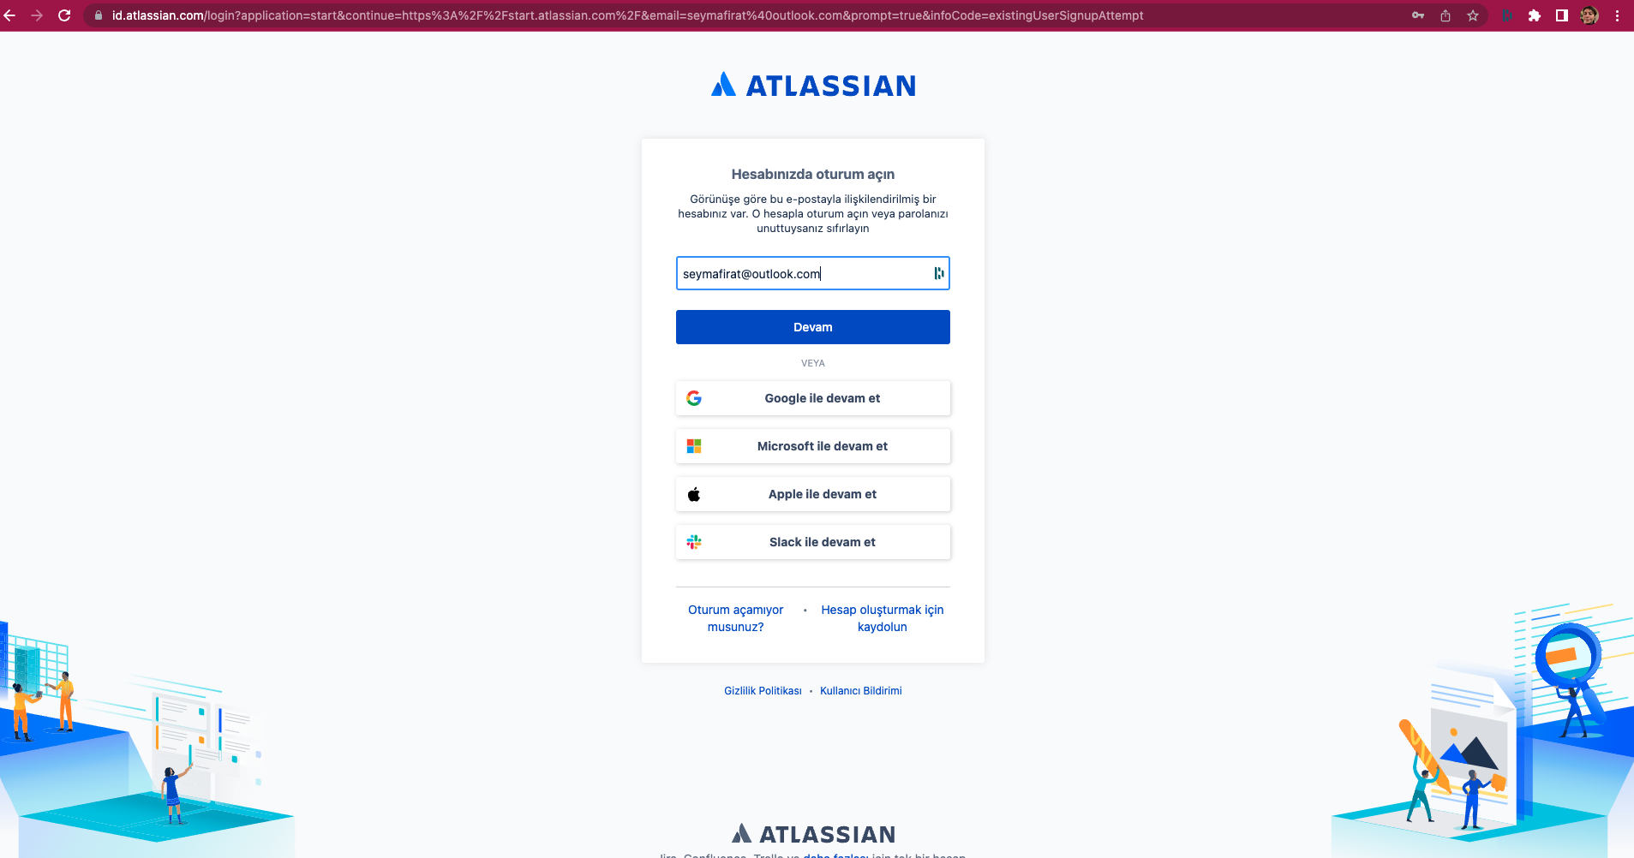

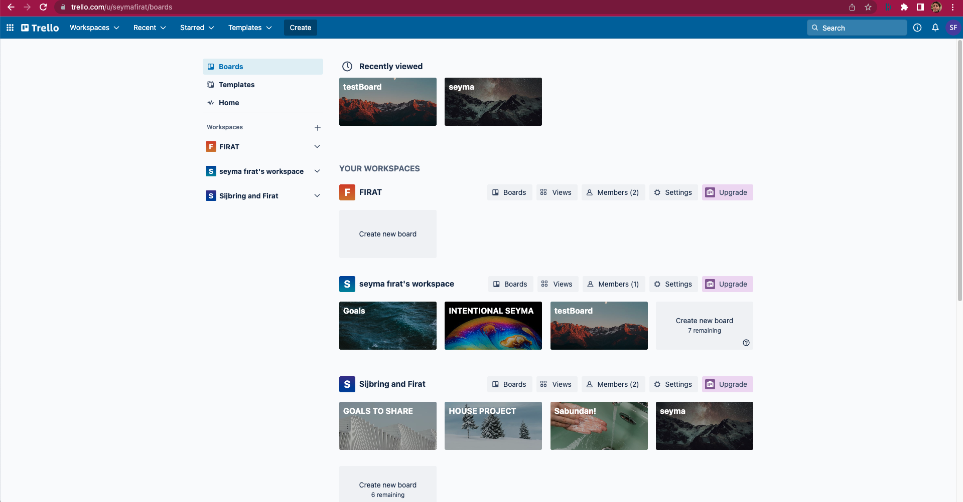

ST-2

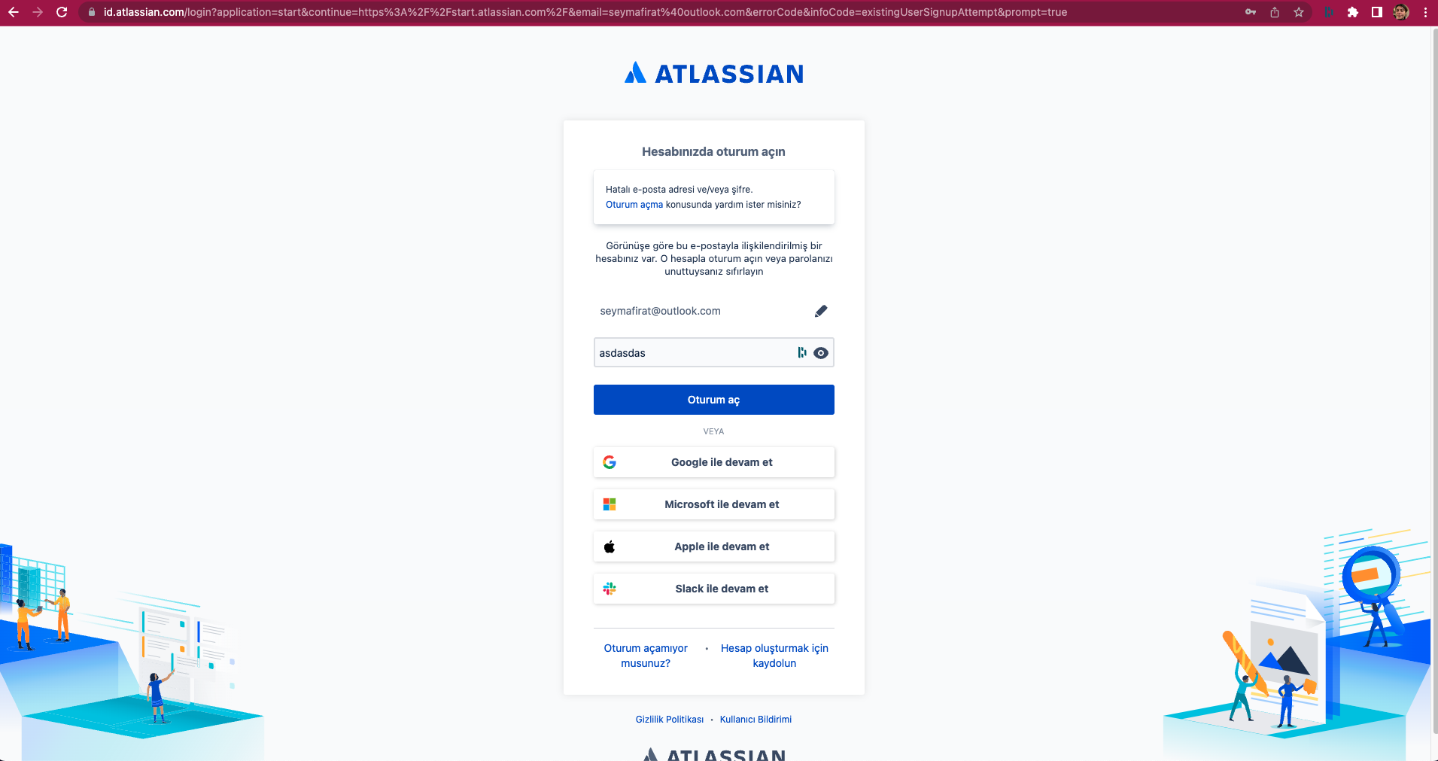

ST-3

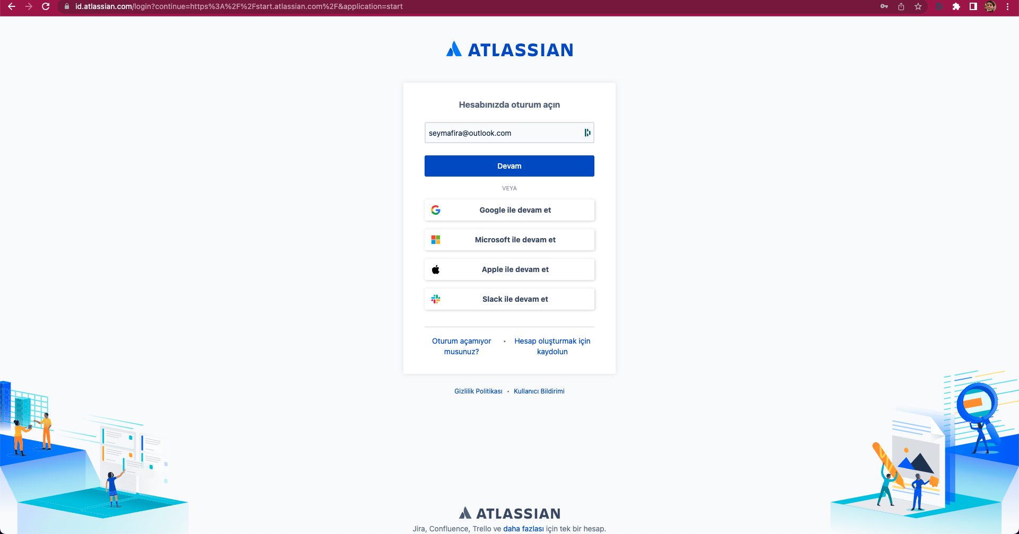

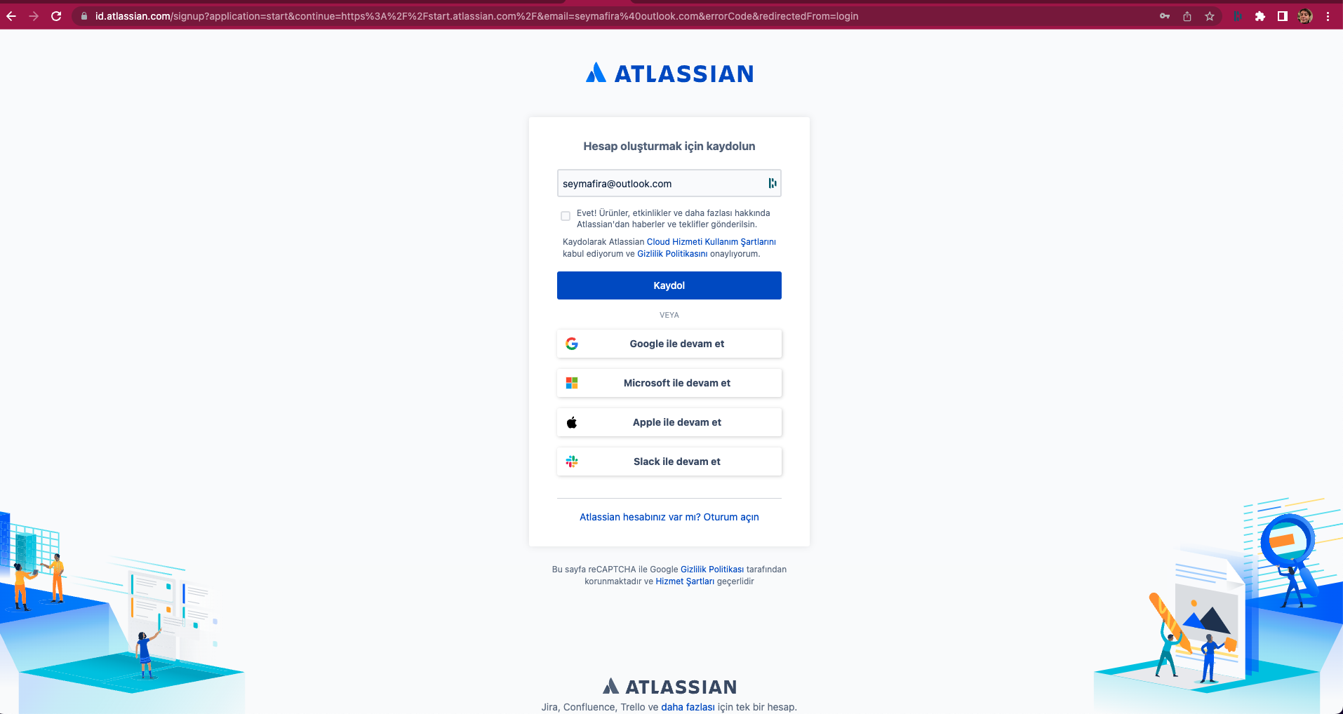

ST-4

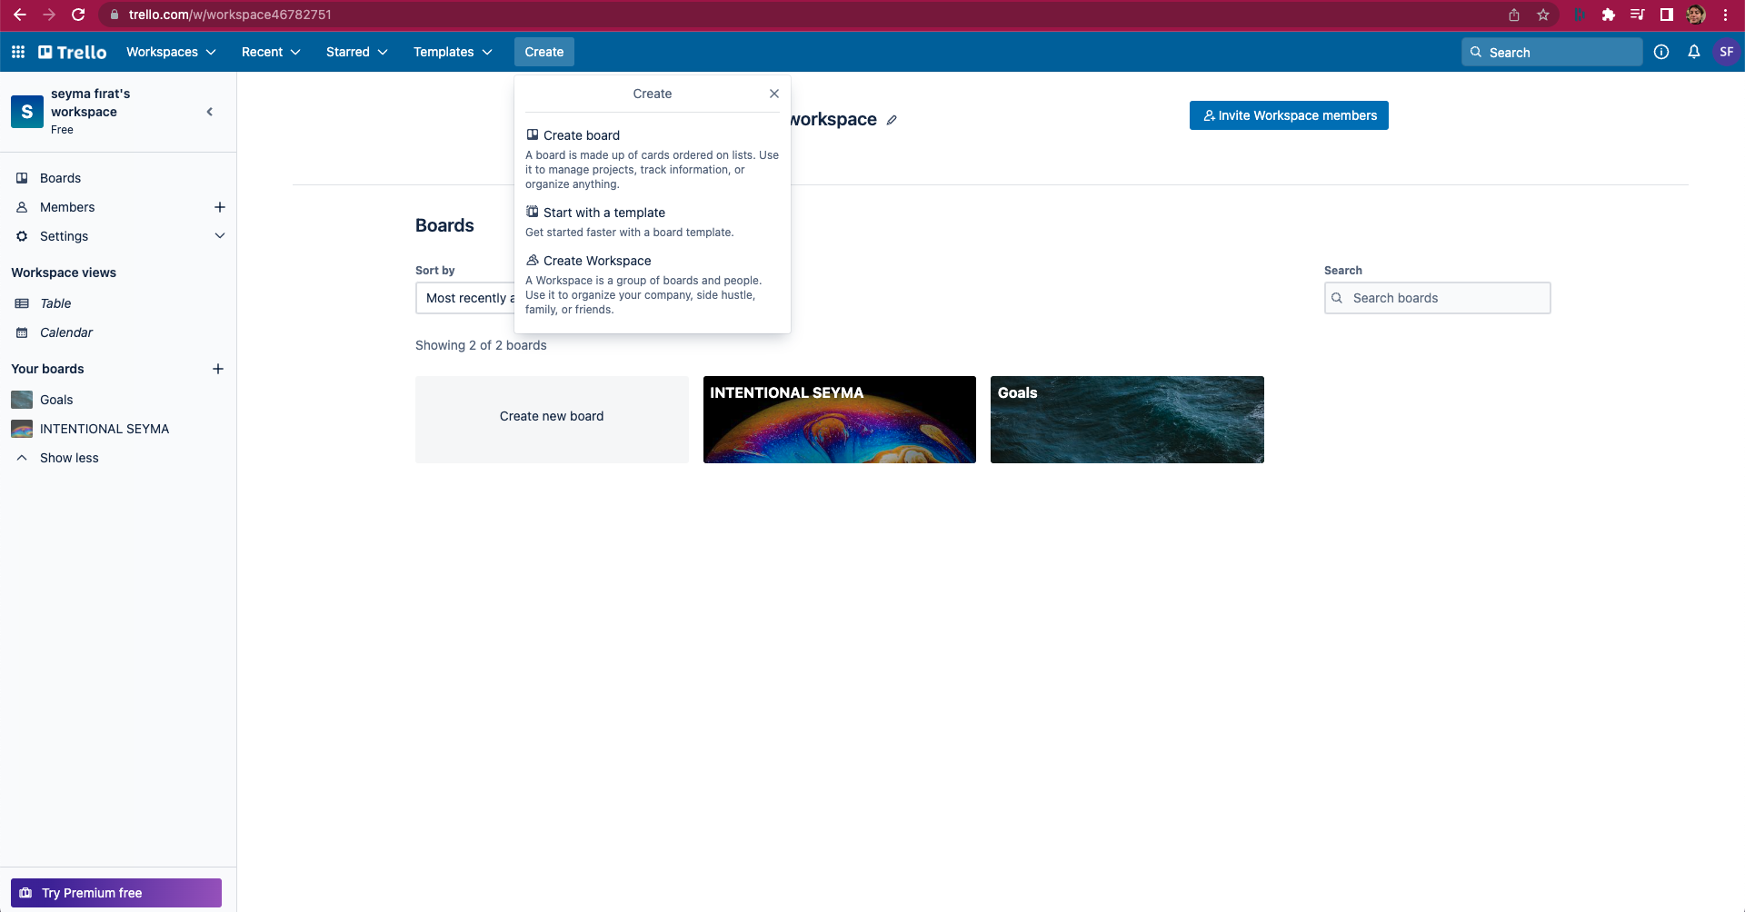

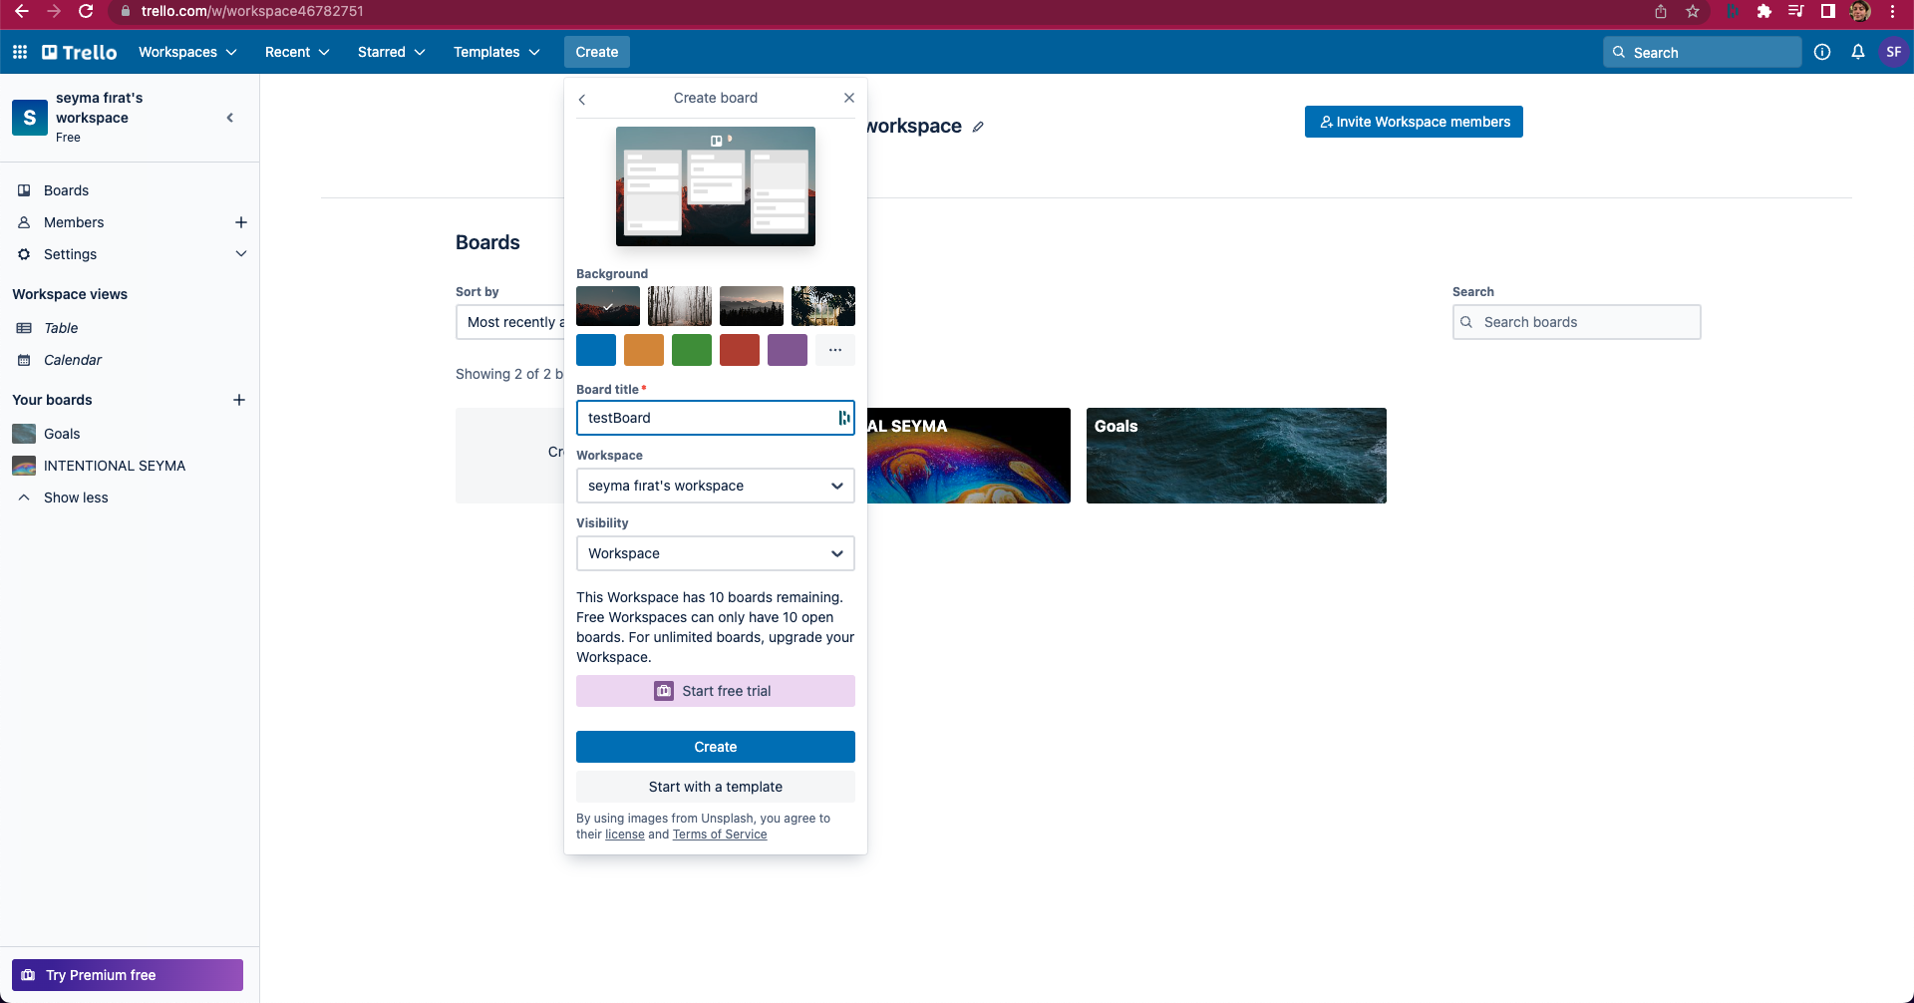

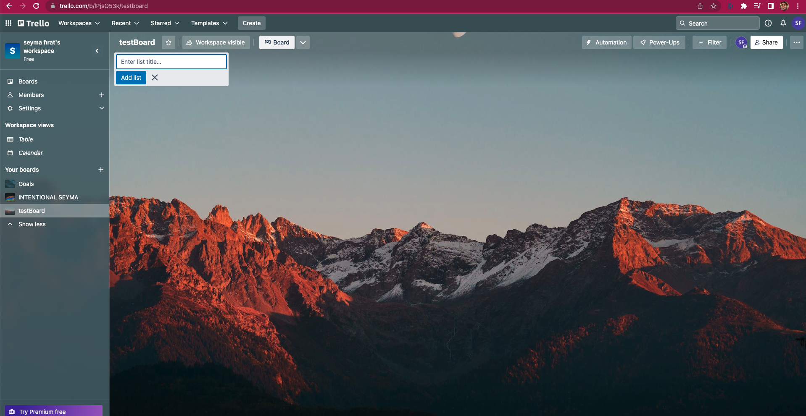

ST-5

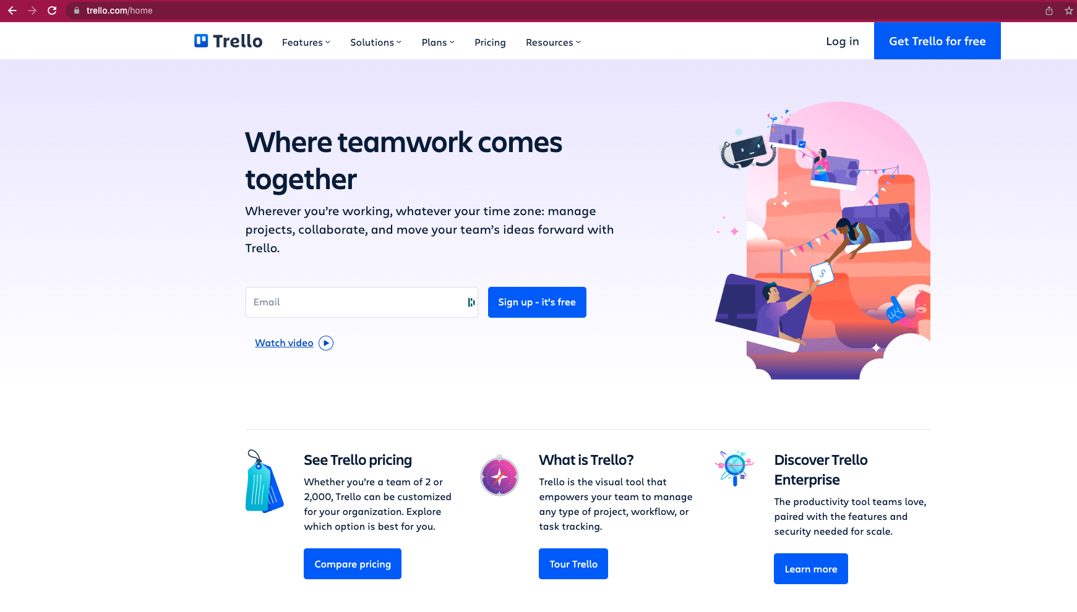

ST-6

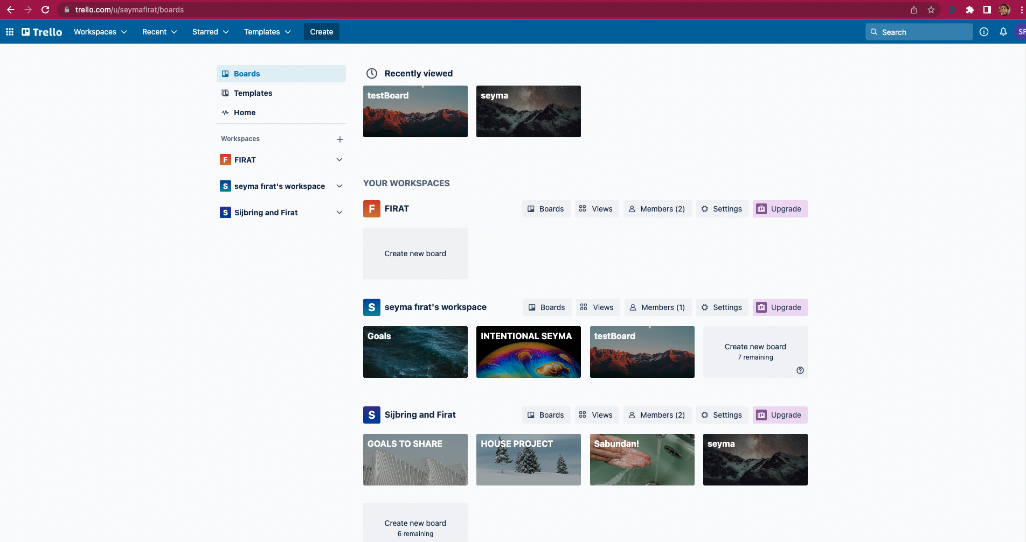

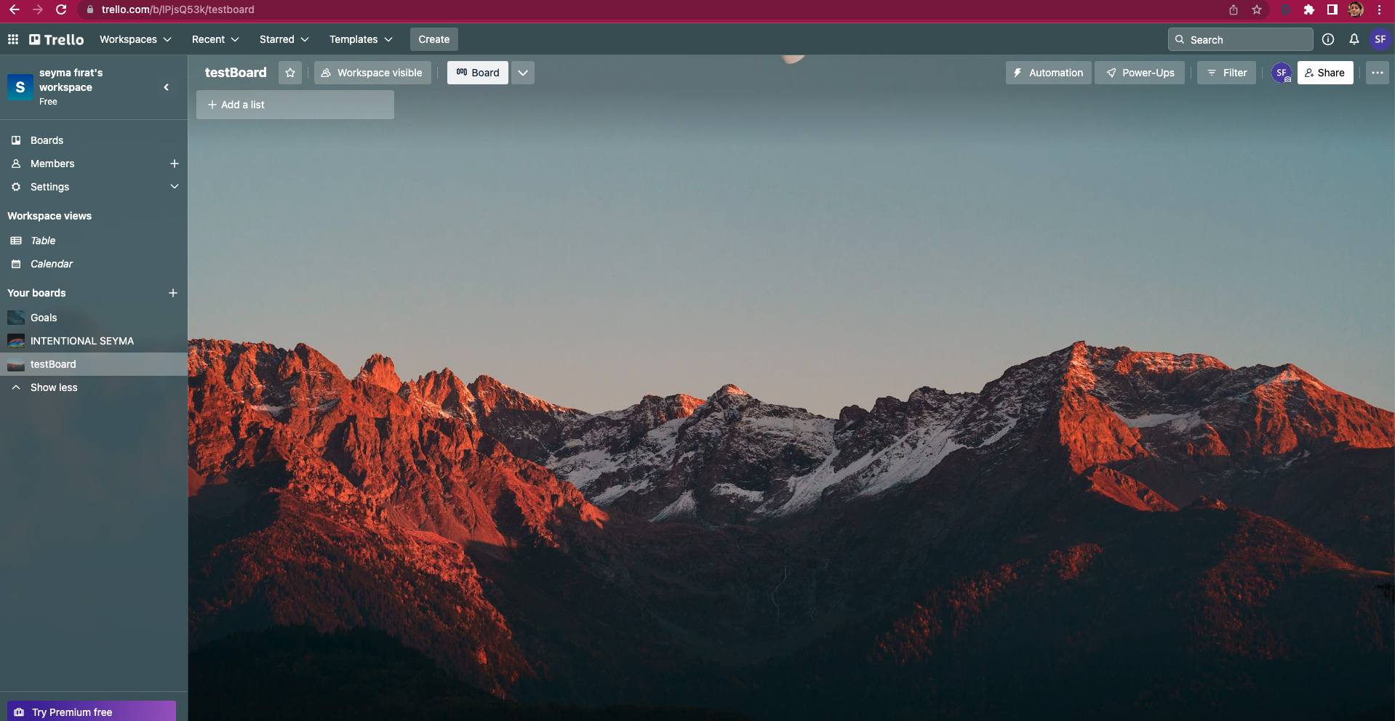

ST-7

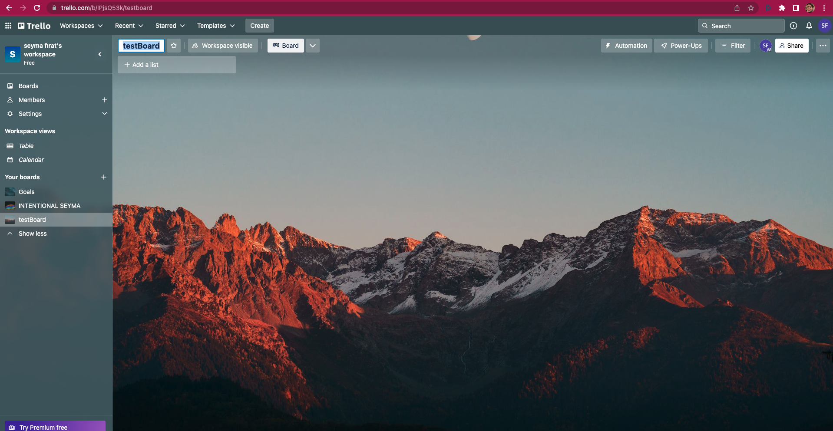

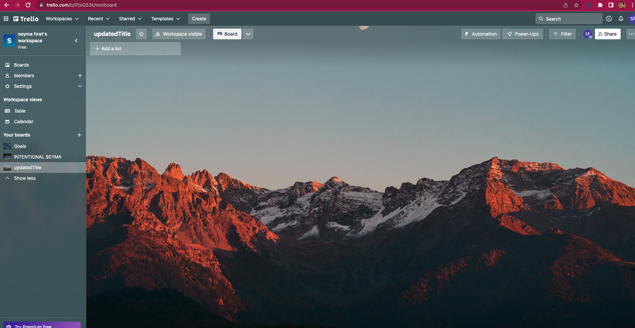

ST-8

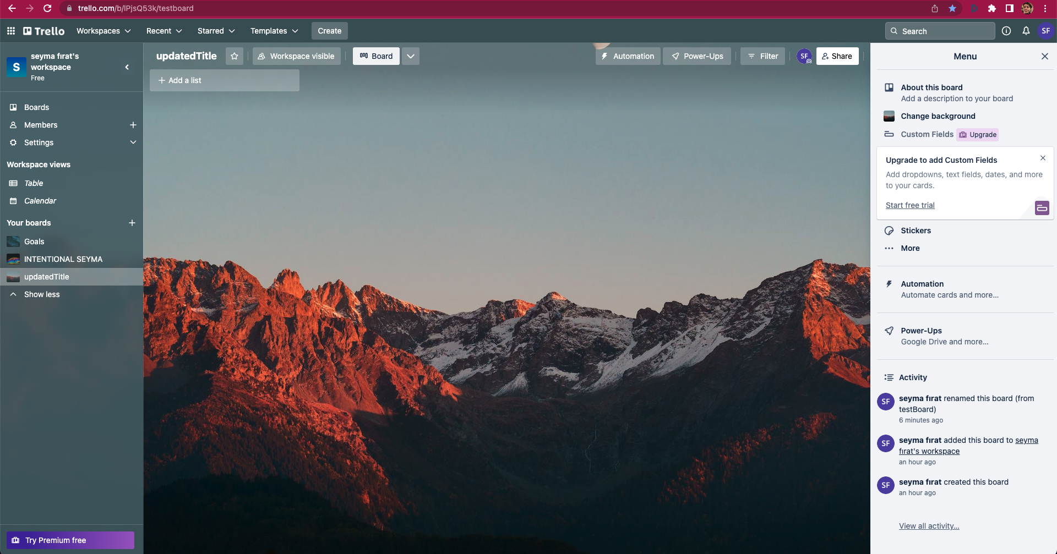

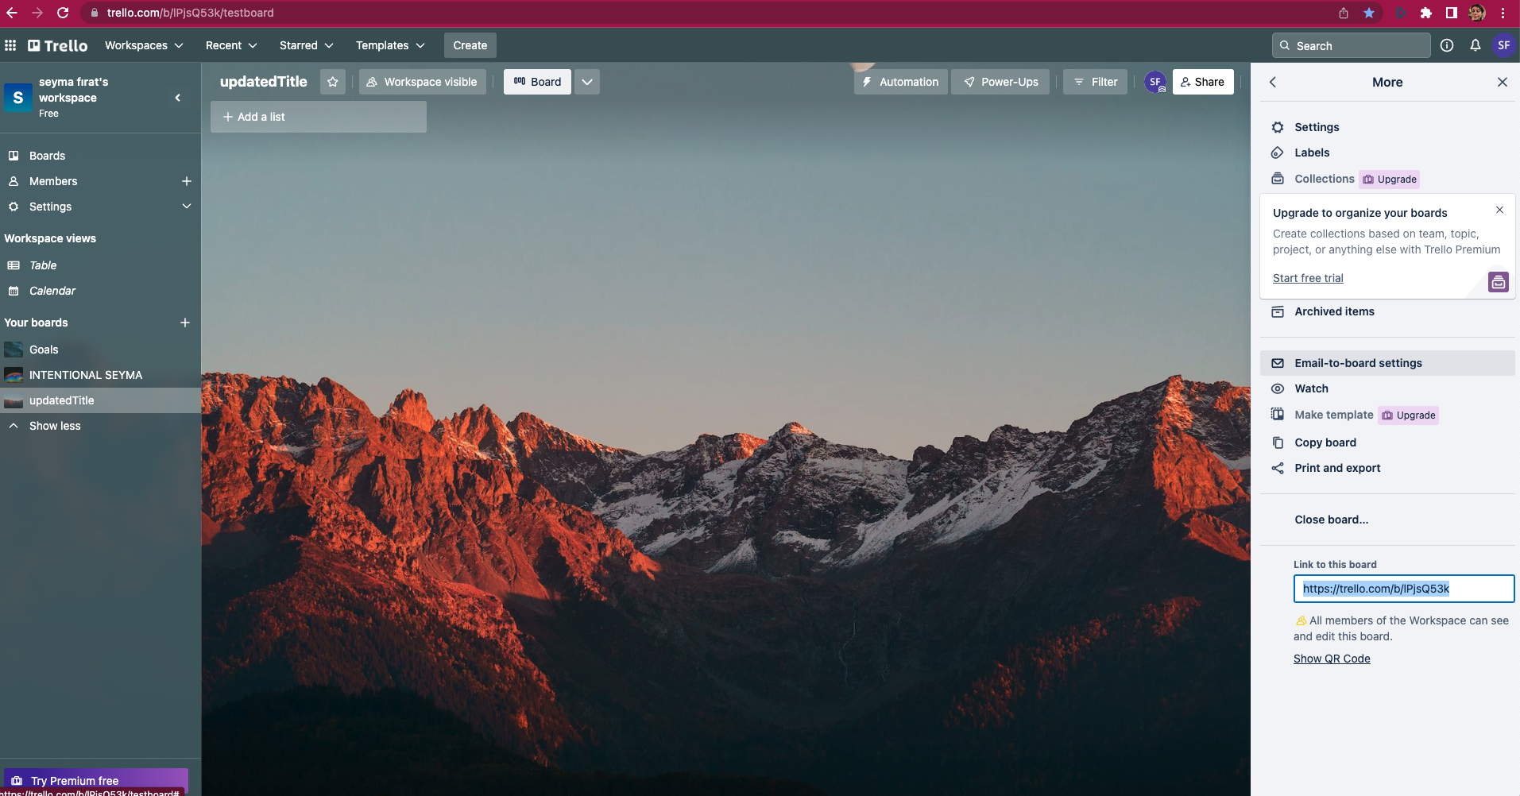

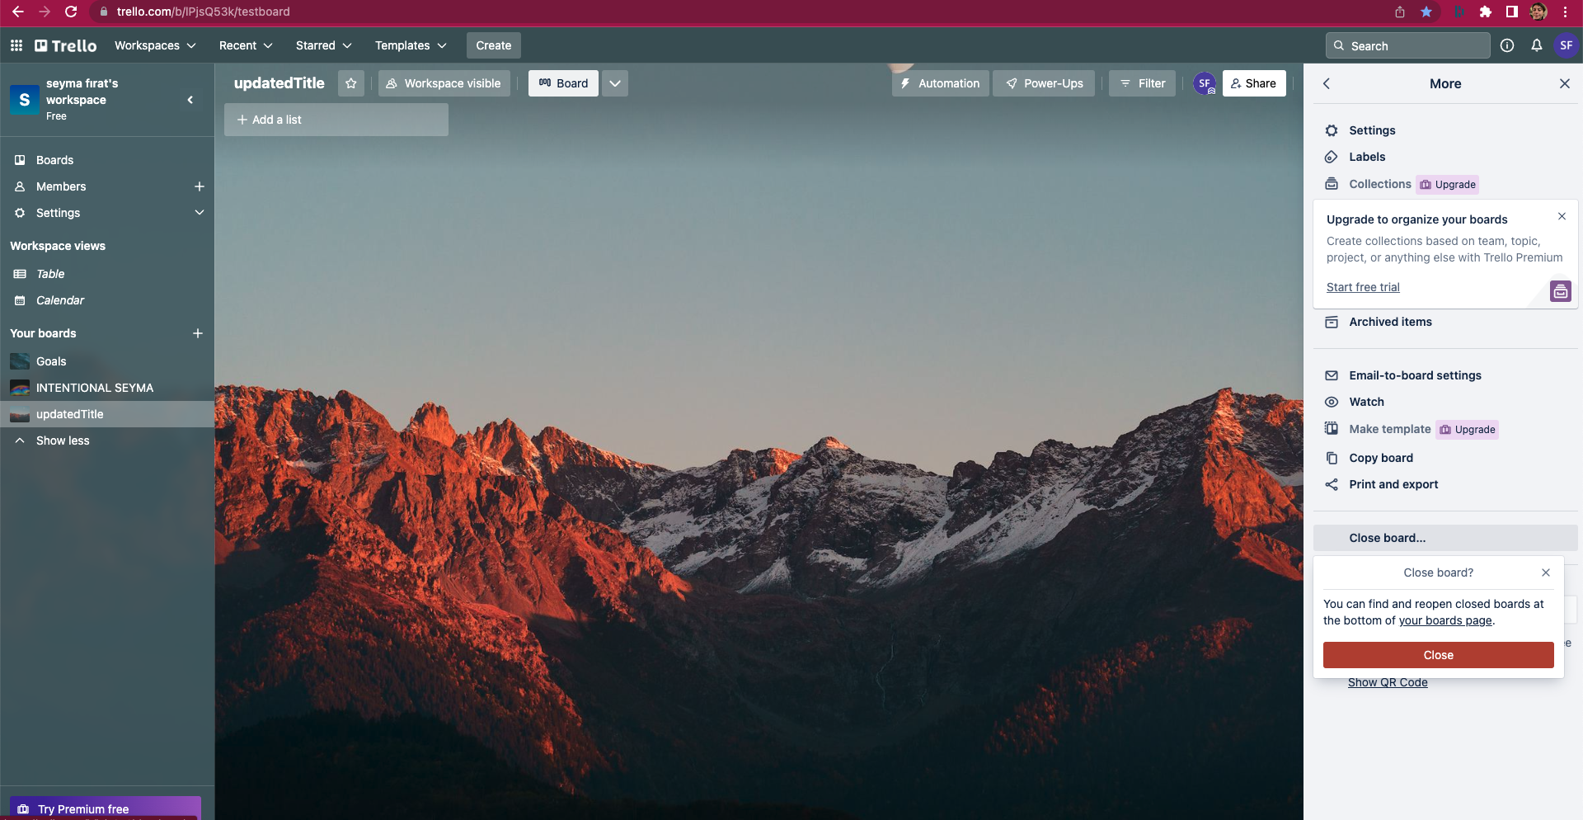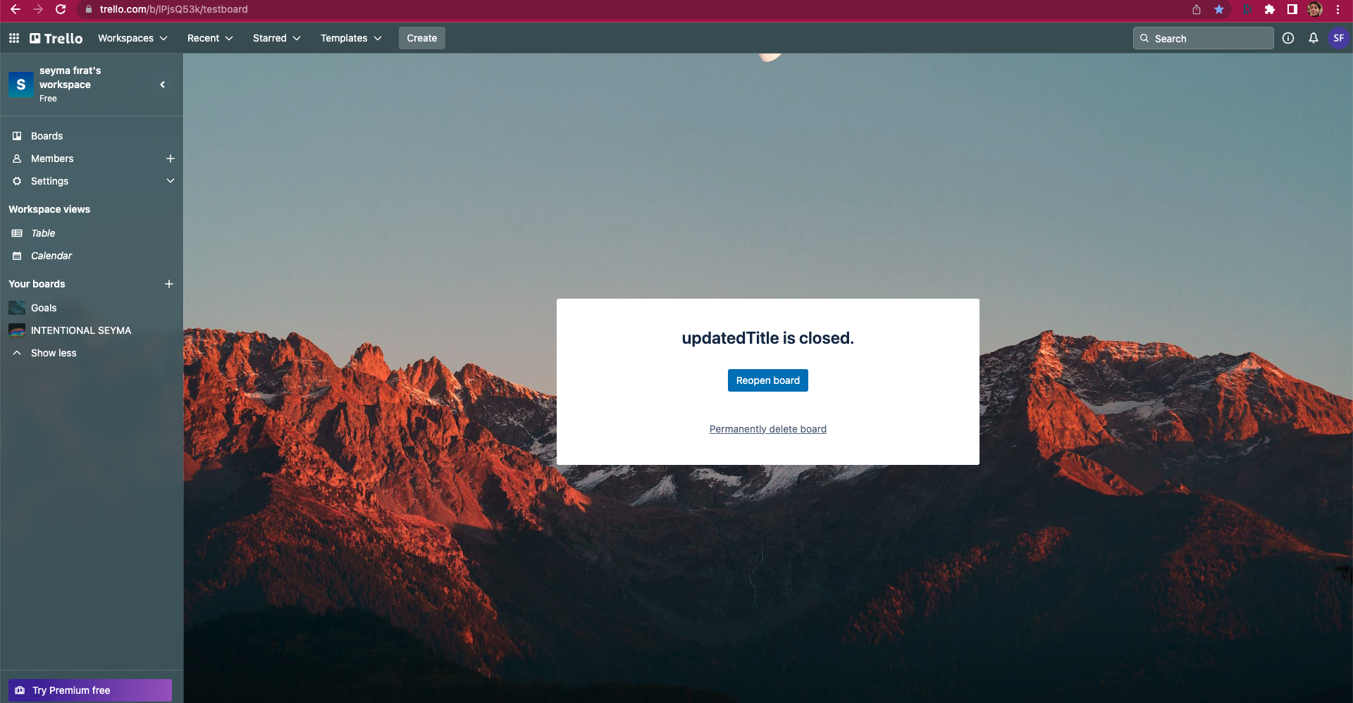

ST-9

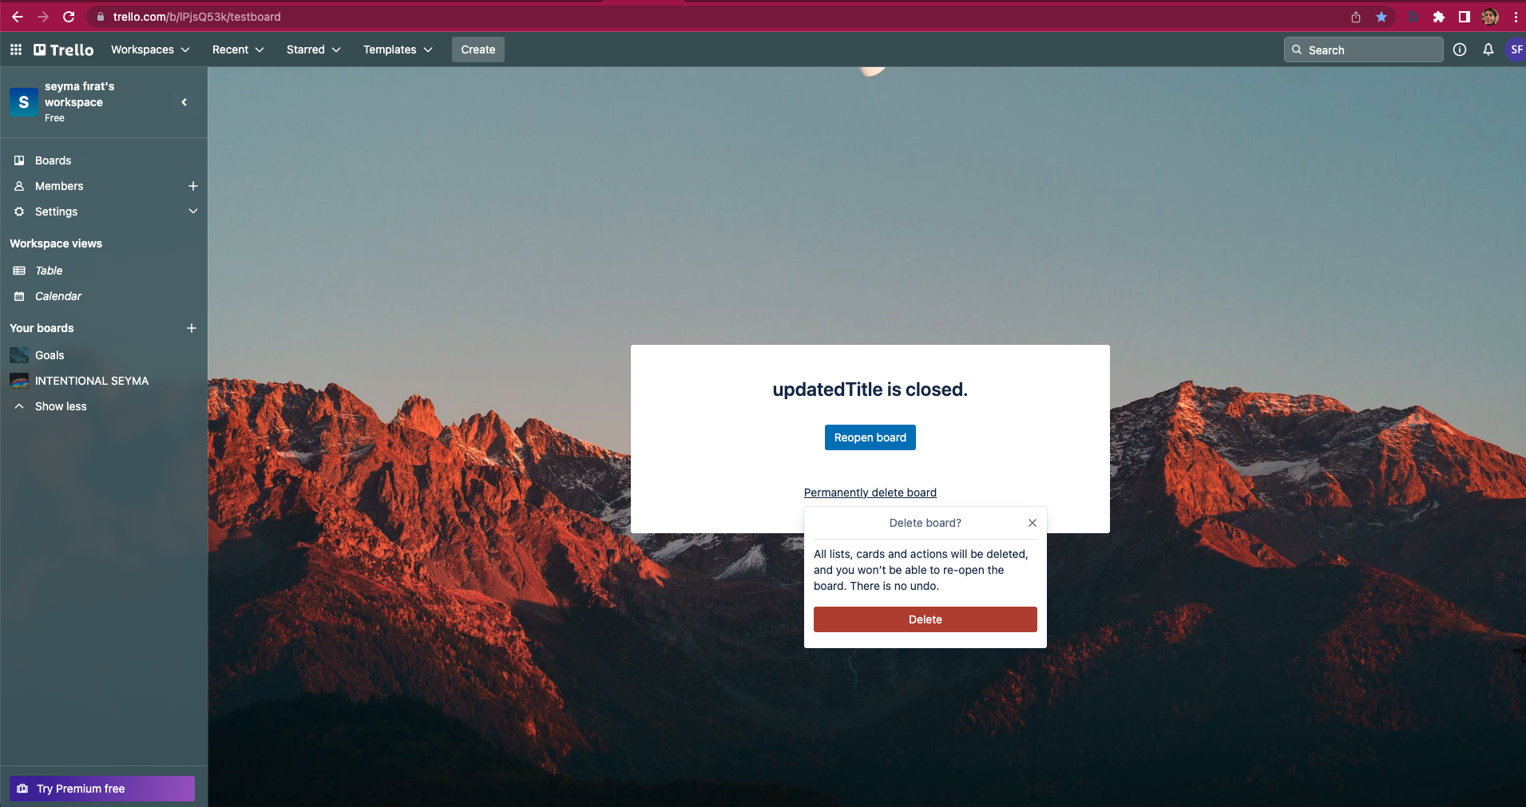

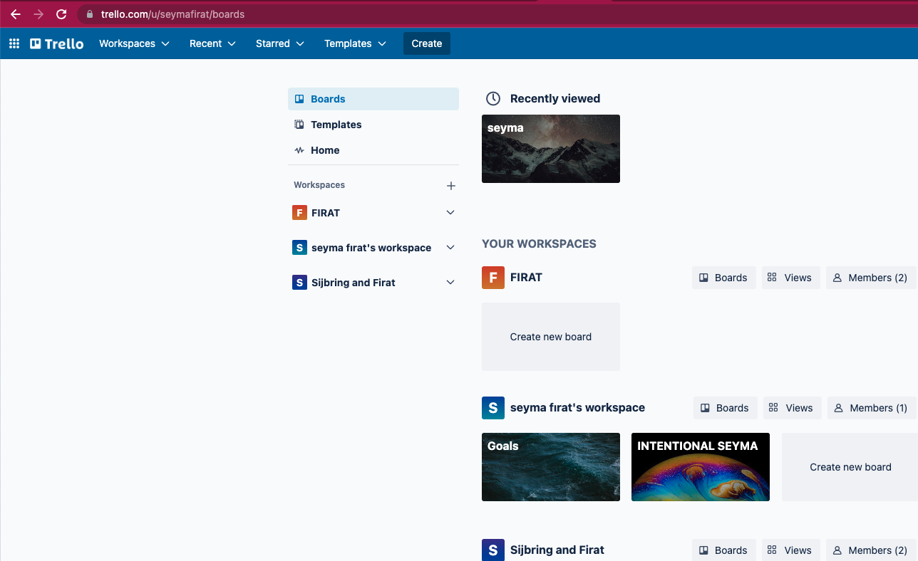

ST-10

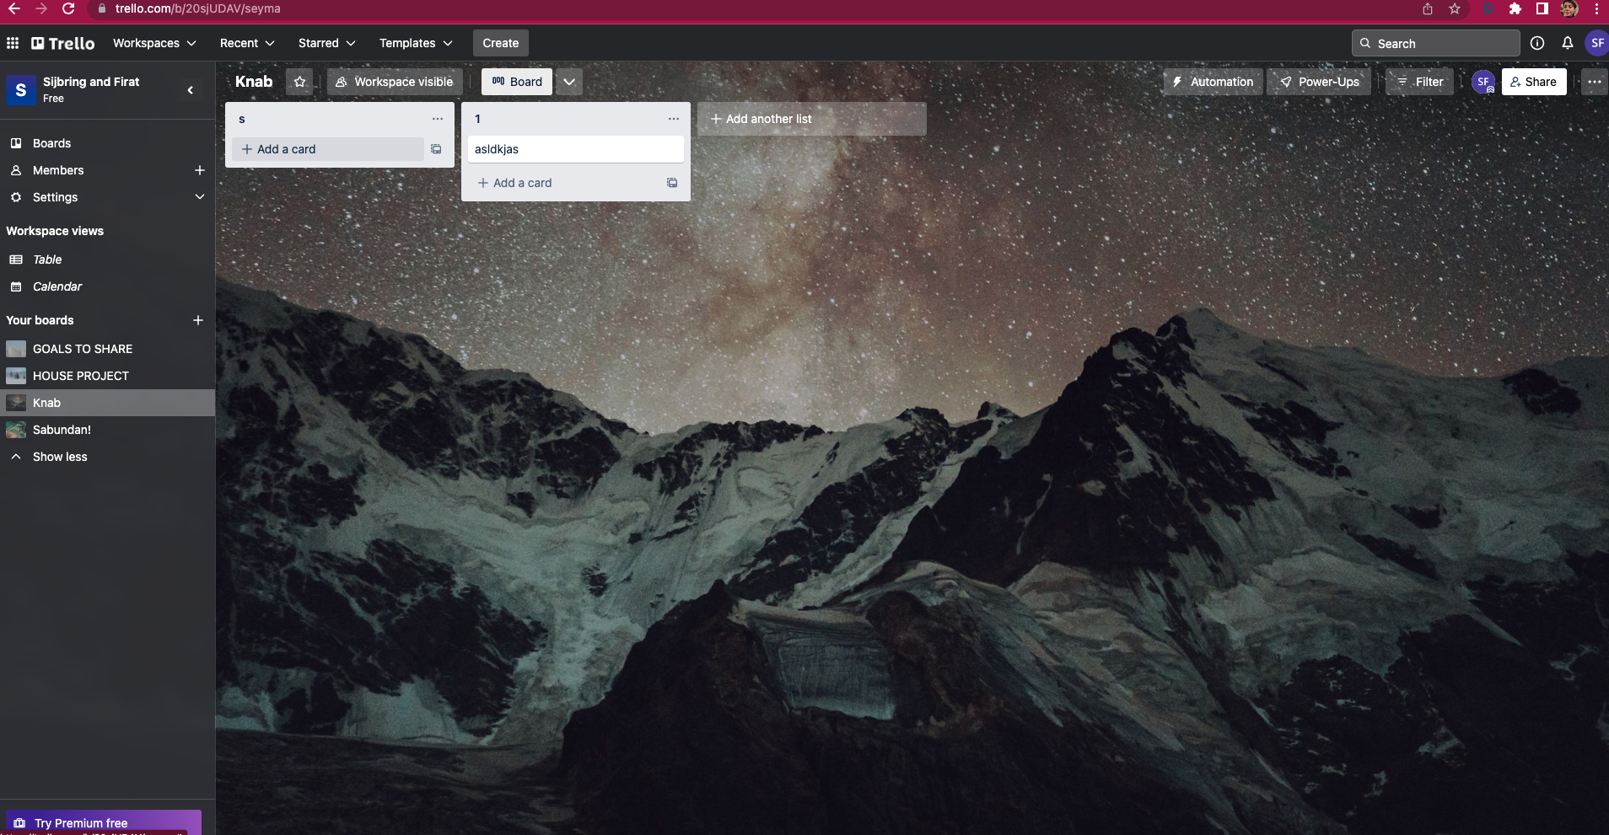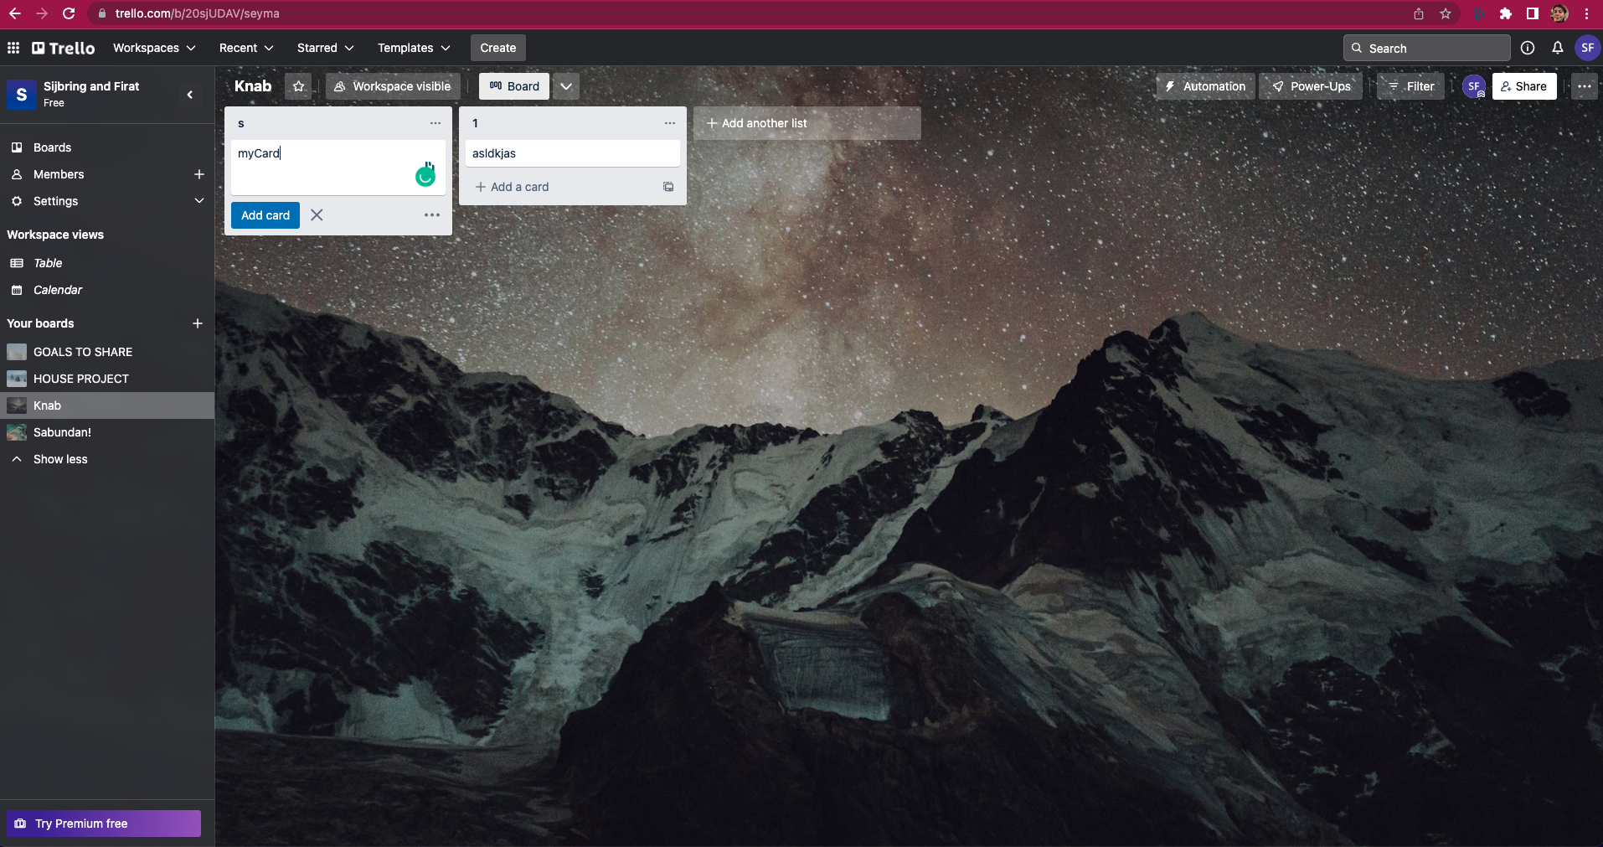

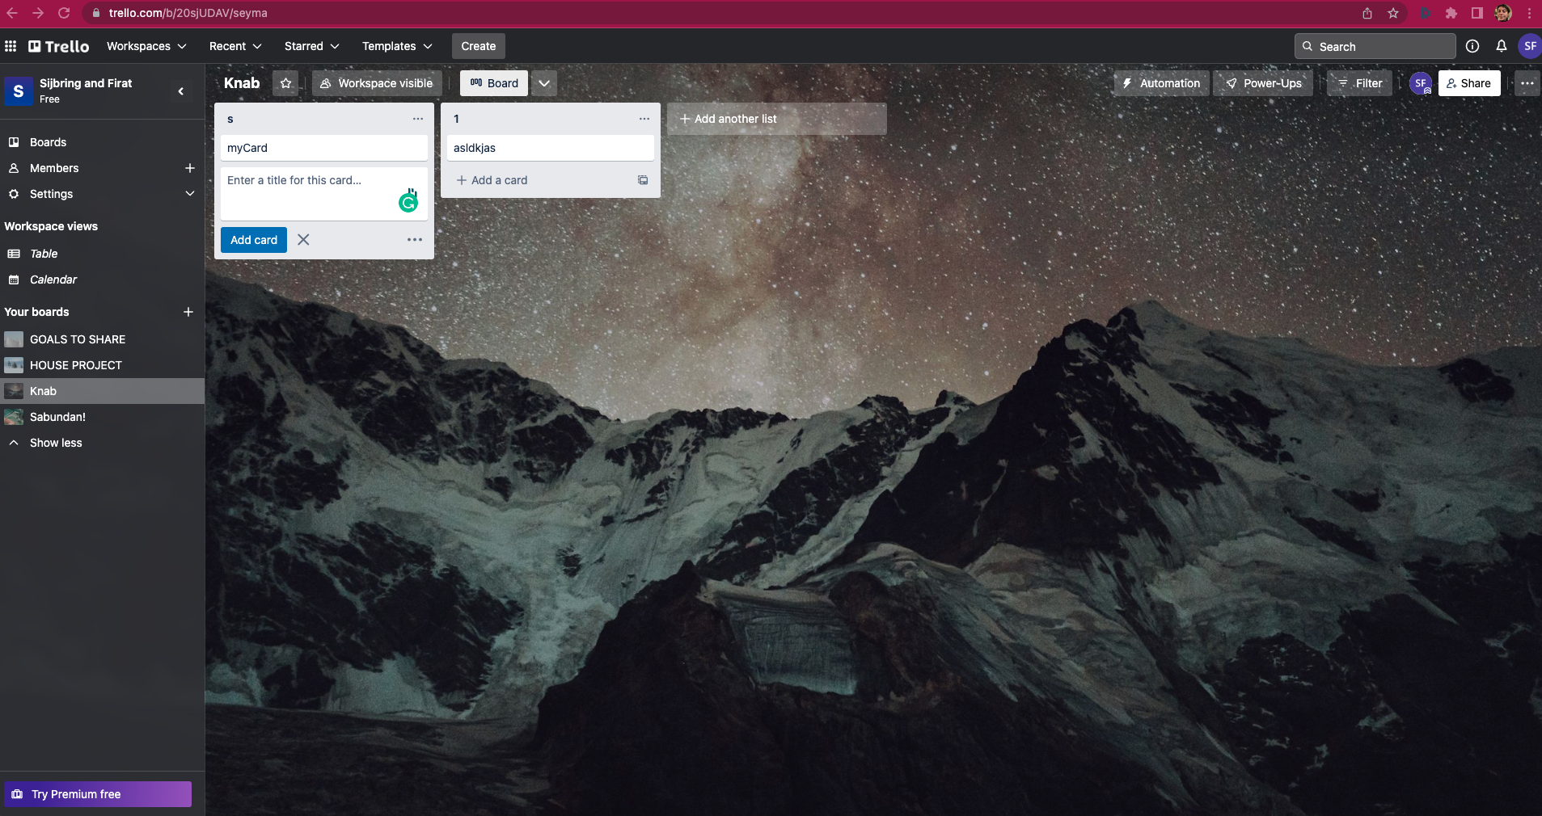

ST-11

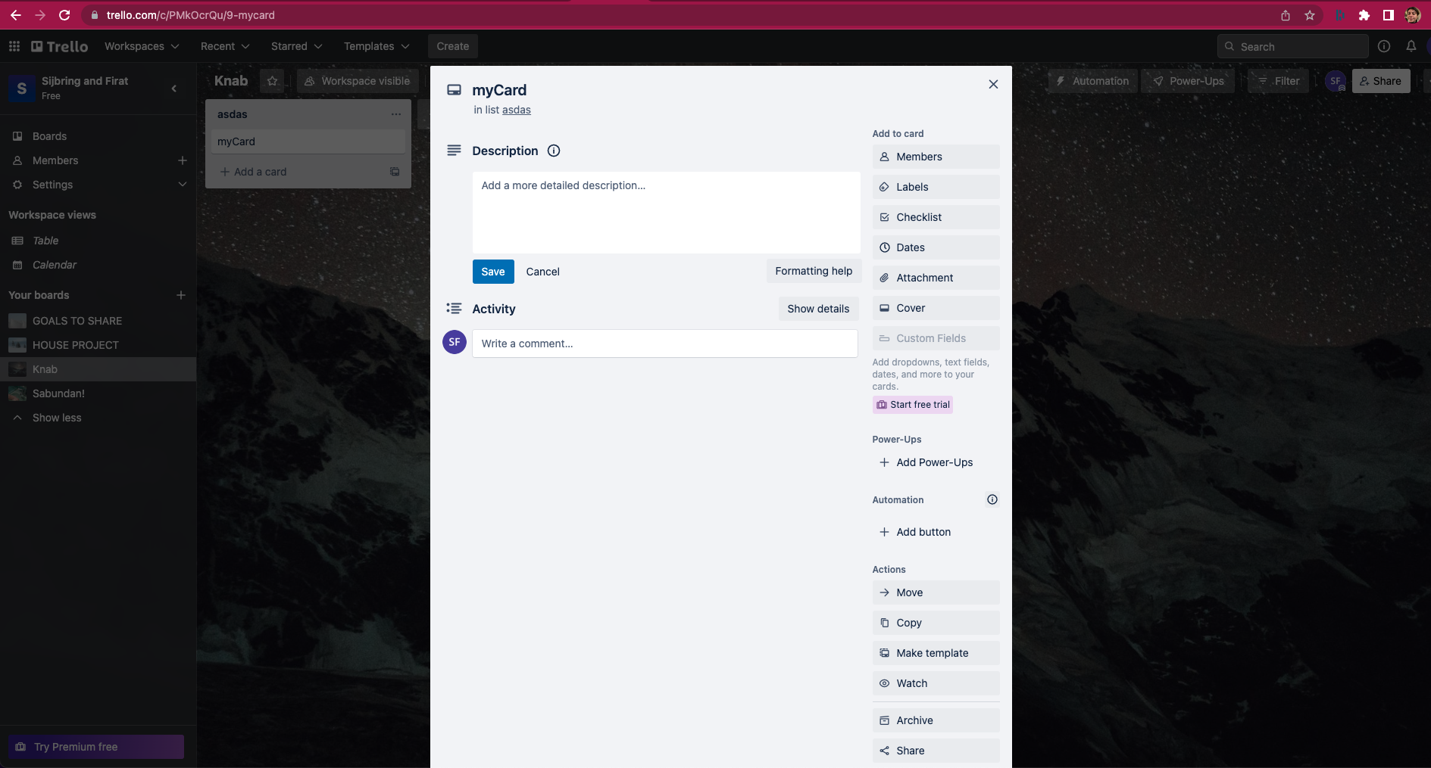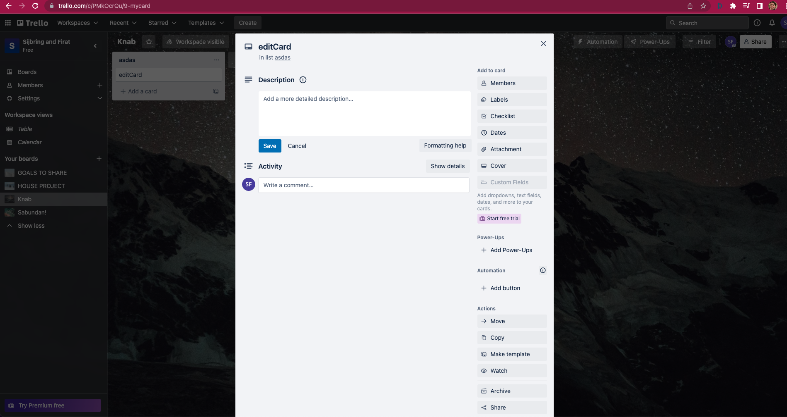

ST-12

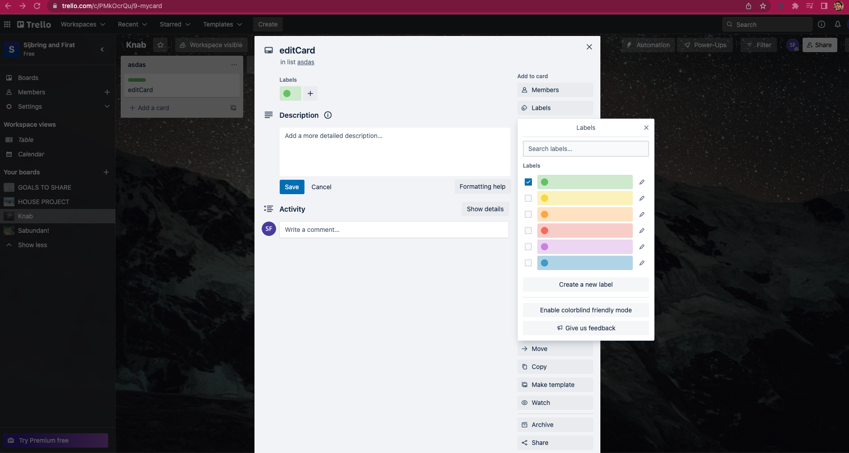

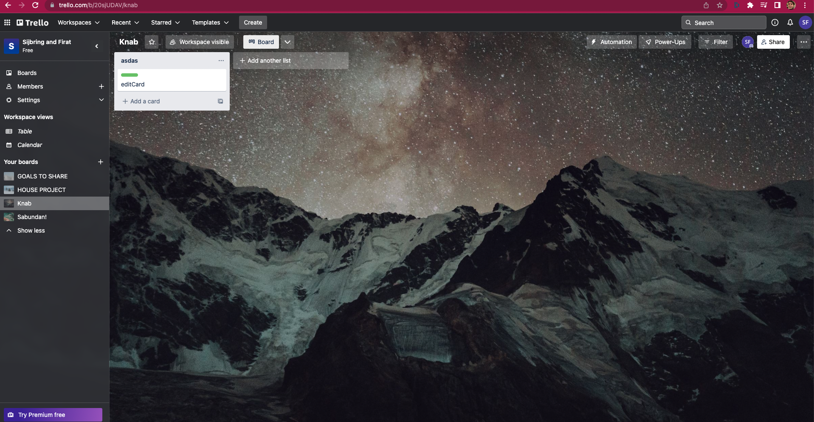

ST-13

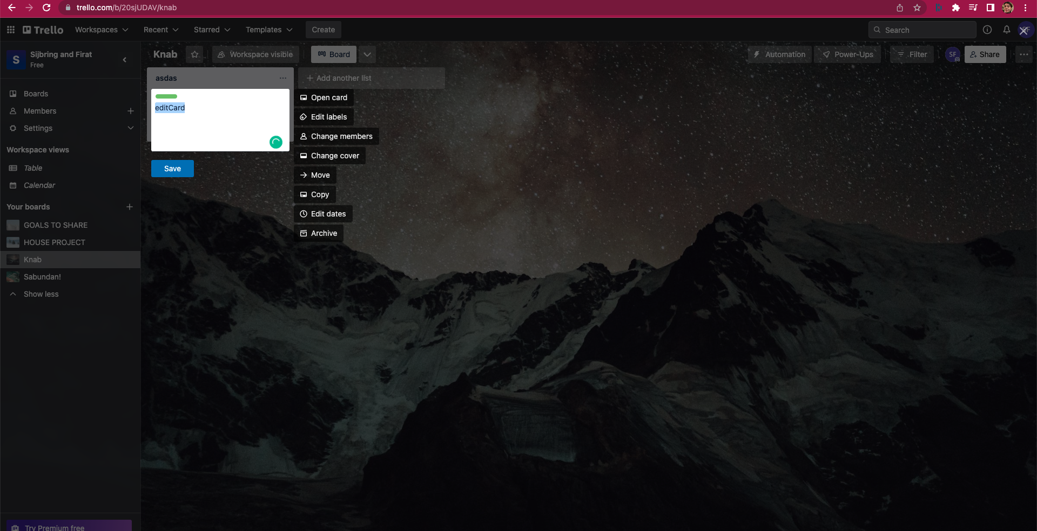

ST-14



ST-15

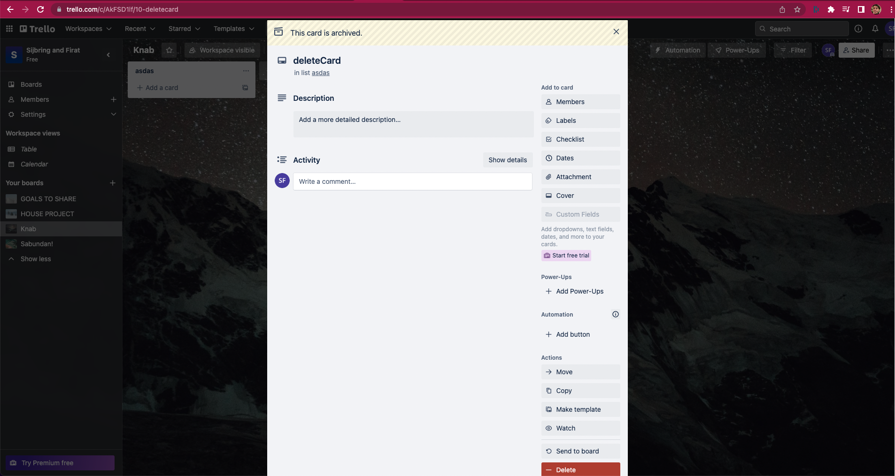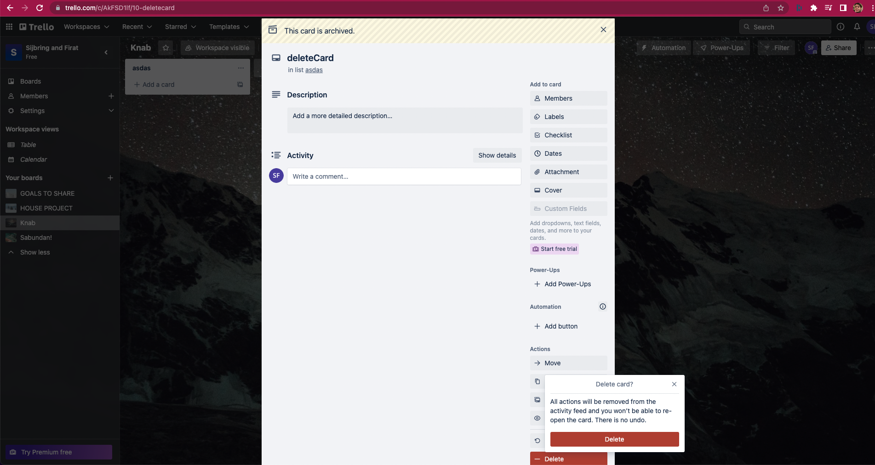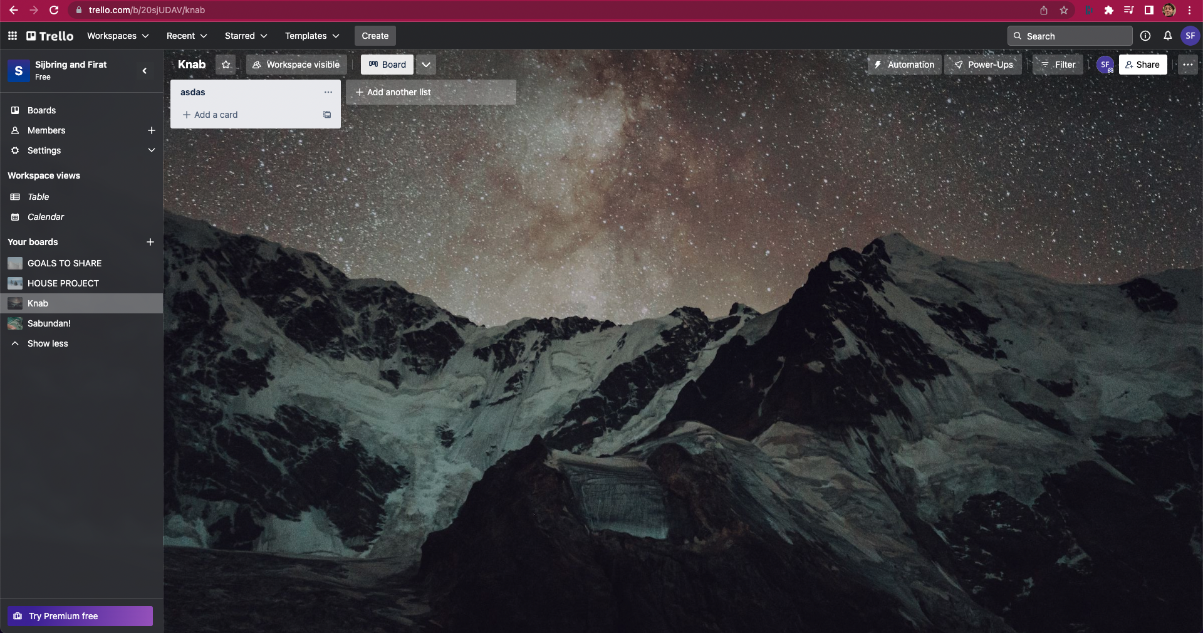

ST-16

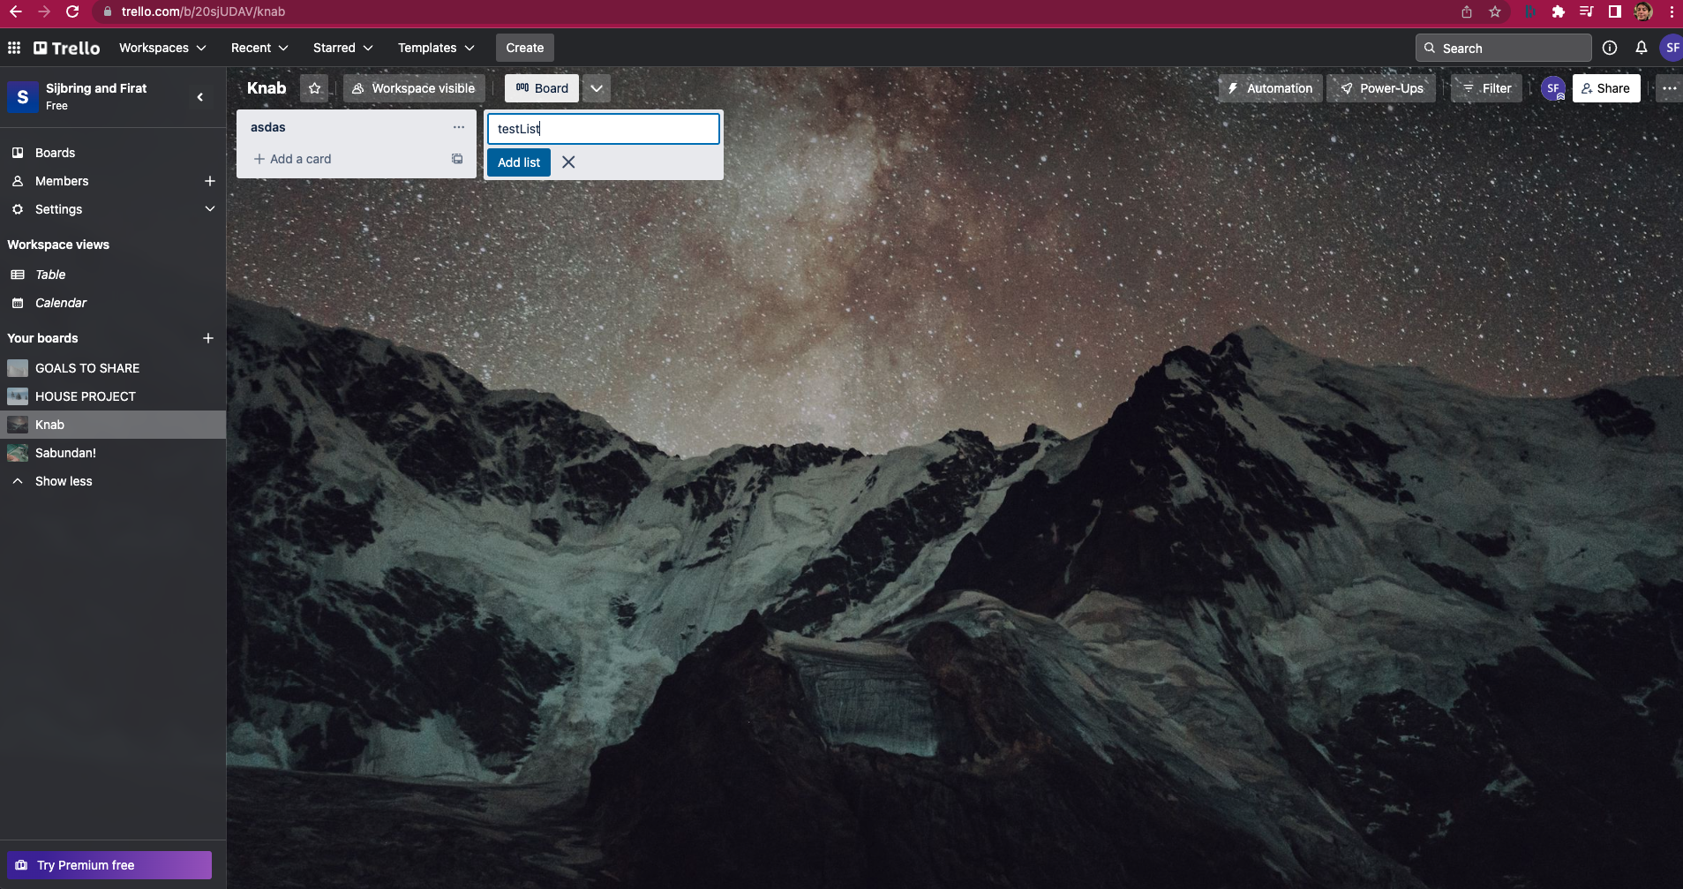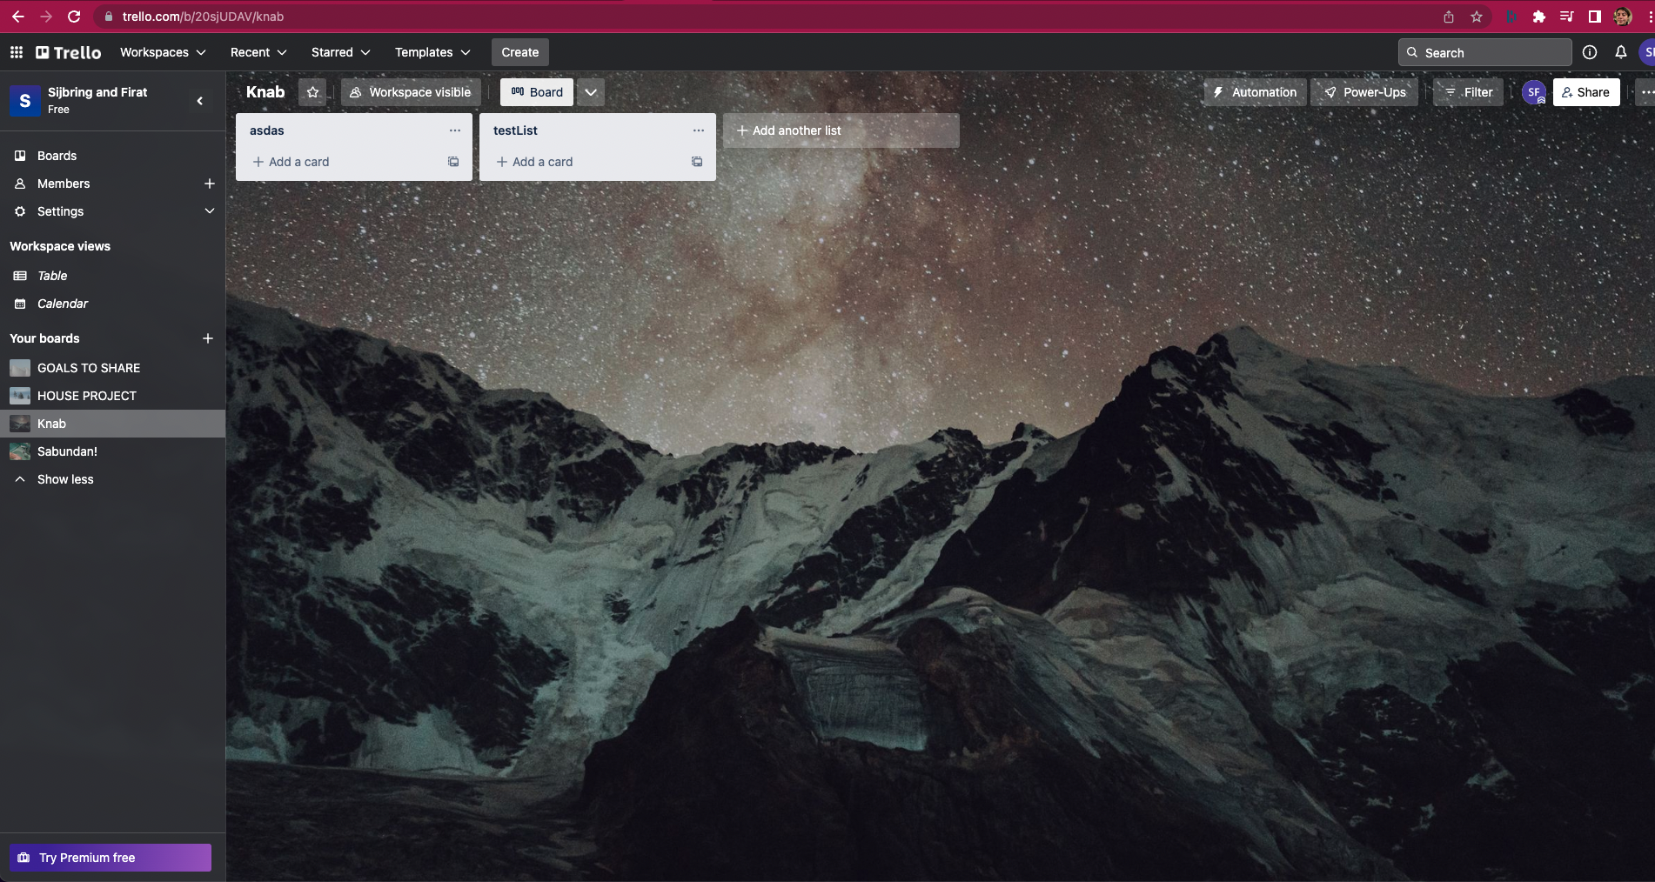

ST-17

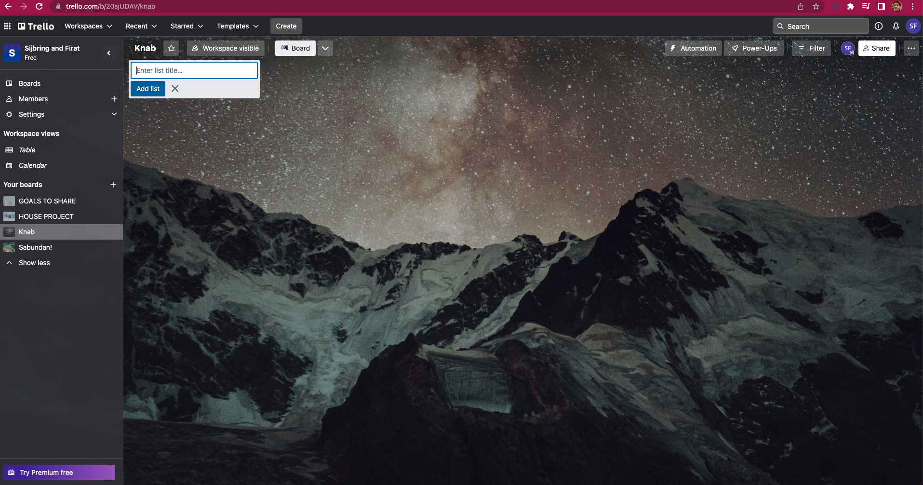

ST-18

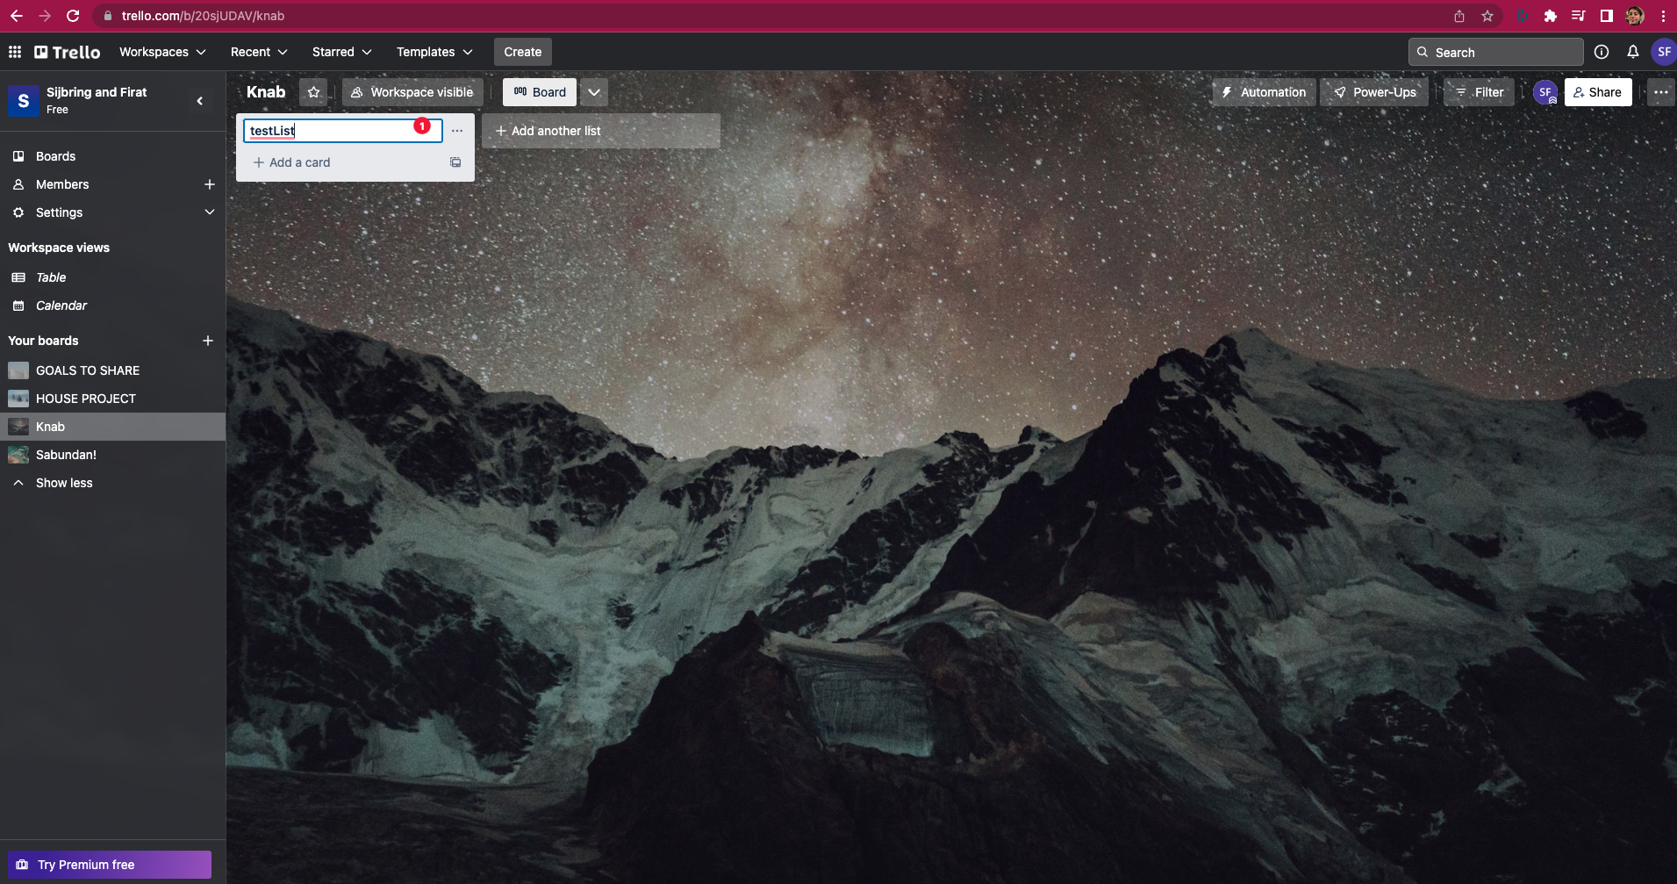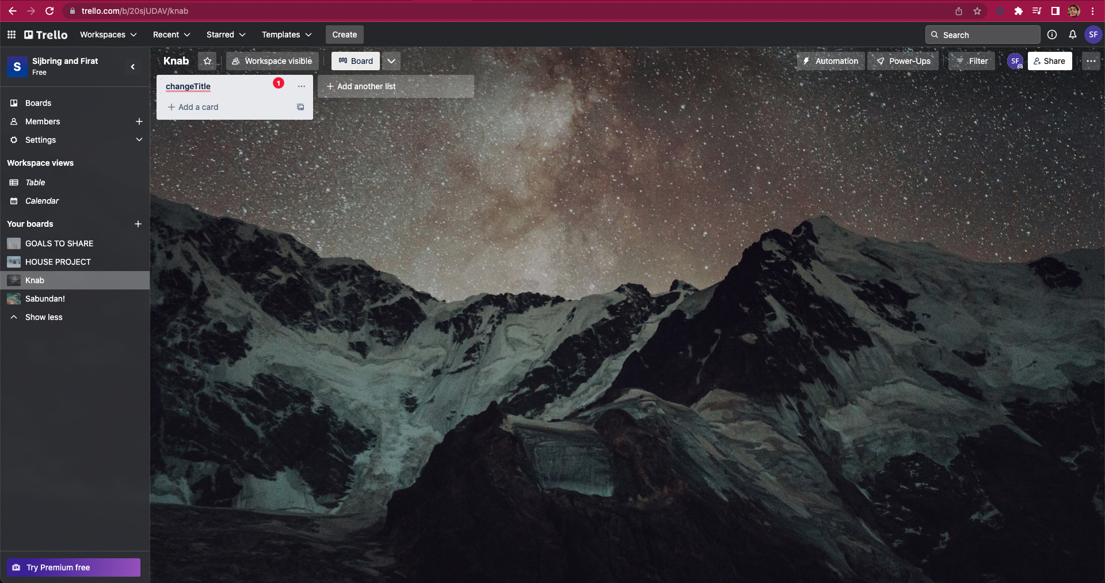

ST-19

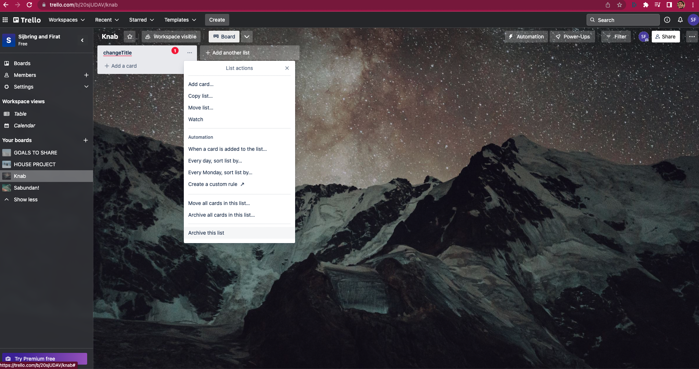

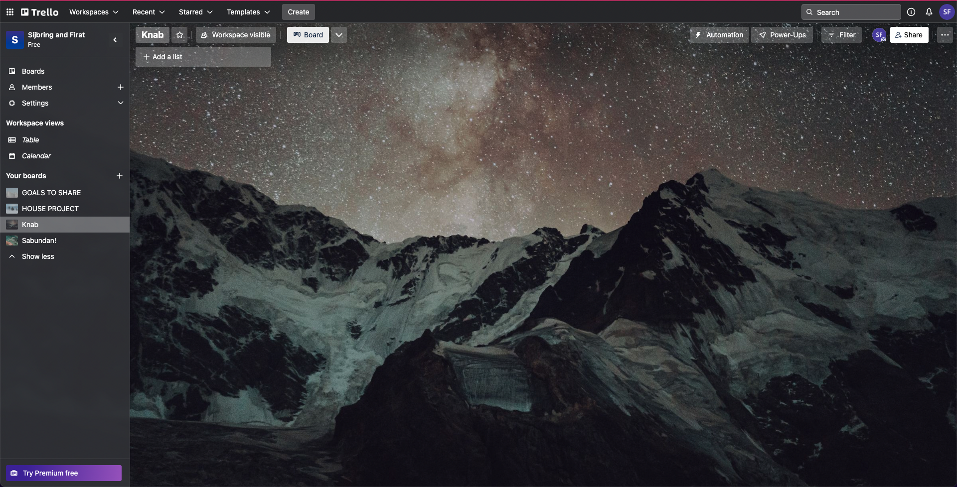 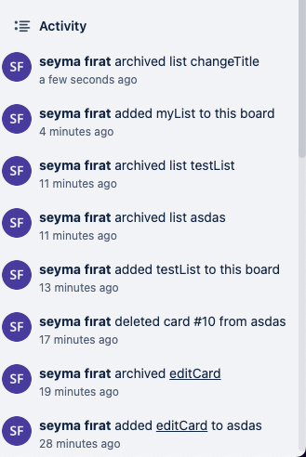

1. Defects found during the system testing
2. Summary and conclusion
3. Definitions & References
   1. Definitions

Definitions used in this document:

|  |  |
| --- | --- |
| **Concept** | **Description** |
| Verification | Check that the requirements are correctly implemented in the design of the product |

* 1. Document history

|  |  |  |  |
| --- | --- | --- | --- |
| **Rev** | **Date** | **Author** | **Description** |
| 1.0 | 09/10/2022 | Seyma Firat | Initial version |